**APPLICATION DEVELOPMENT FOR FINDING FLATMATES**

**MOBILE APP OPTIMIZATION FOR PLAYSTORE/APP STORE**

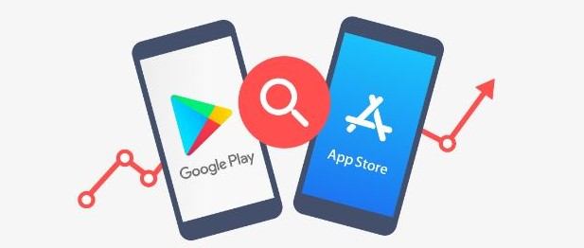

**Whenever you develop a mobile application, you want to give it the best chance of success and make sure you can reach as many users as possible.**

**What is app store optimization (ASO)?**

**App Store Optimization (ASO) refers to the process of improving your mobile application’s visibility in app stores. ASO focuses on boosting your app performance in app store search results and click-through rates (CTR), which can translate to the success of your mobile app. If you’ve heard of SEO before, then ASO is basically app store SEO, and can help in**[**optimizing mobile apps for better business performance**](https://www.netguru.com/blog/promote-mobile-app-for-free)**.**

**Mentioned below are some of the best techniques for optimization of mobile app for PLAYSTORE/APP STORE:**

**1. Add app preview video to increase user engagement:**

**Most app marketing tactics consist of text, images and video. Of these three, video proves to produce higher user engagement, as evidenced by the huge sums of money paid to produce and distribute in online video ads. In 2021 for example,**[**digital video advertising spending in the US alone was estimated an USD55.34 billion**](https://www.statista.com/statistics/256272/digital-video-advertising-spending-in-the-us/#:~:text=In%202021%2C%20digital%20video%20advertising,by%20the%20end%20of%202023.)**.**

**Headspace, for example went as far as creating a Netflix series, using the same branding, colour schemes and imagery, which presents a unified visual approach with their app, so if someone searches for "meditation app", they will immediately recognise the brand from the screenshots or video previews used.**

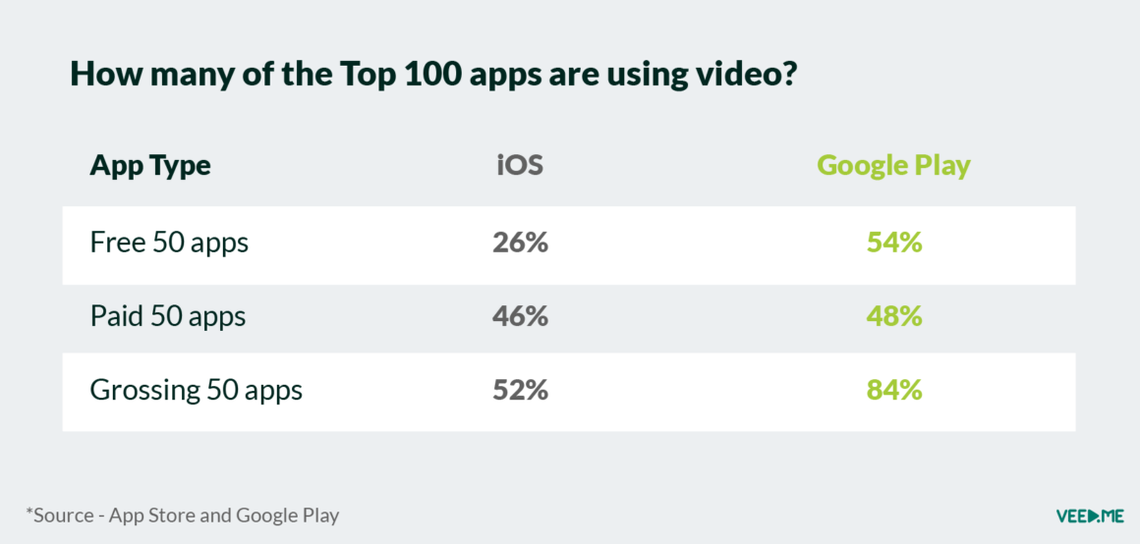

**This comes with an added bonus: Google Play Store video plays add to your YouTube video play count. So, you’re not only boosting your ASO, but also ranking your YouTube video better.**

**2. Aim for keywords with the right volume-to-click-through ratio:**

**When you’re starting off with app store optimization, you don’t want to make the mistake of focusing only on using keywords with the highest possible search volume in the app description.**

**While it’s certainly important, not all of such phrases receive an adequate amount of clicks from users. The number of clicks you receive is known as click-through rate (CTR). CTR is the ratio of users who click a link versus the total number of users who visit the page that hosts the link.**

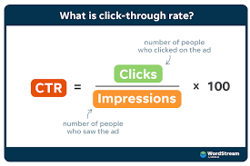

**Choosing a low-CTR phrase can potentially harm your app store listing. If you don’t get enough clicks – Play Store might determine it as irrelevant to users.**

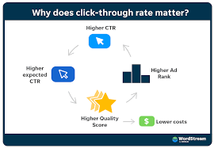

**When choosing your keywords you should also consider your target users’ search intent. Do you expect them to know what your app does? Did they use a similar solution before, or are they new to the subject?**

**An example of a well-thought out user intent strategy is Google Keep’ listing in the Play Store. Despite the app’s immense popularity, its app name in Google Play Store is descriptive: Notes and Lists.**

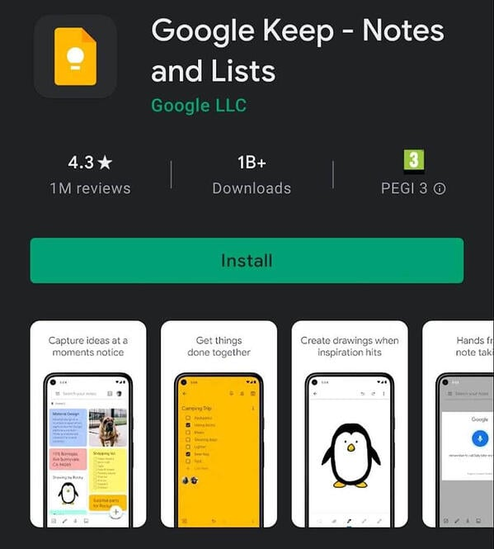

**3. Use long-tail keywords for effective ASO:**

**Given that CTR and user search intent are key ASO factors, you should use long-tail phrases, which are more specific and tend to have a higher CTR. The good news is that by choosing longer keywords you won’t necessarily have to compromise on the search volume!**

**According to an**[**Ahref’s study of over 1.9 billion keywords**](https://ahrefs.com/blog/long-tail-keywords/)**, 29.13% of phrases with over 10,000 monthly searches were made up of three or more word**

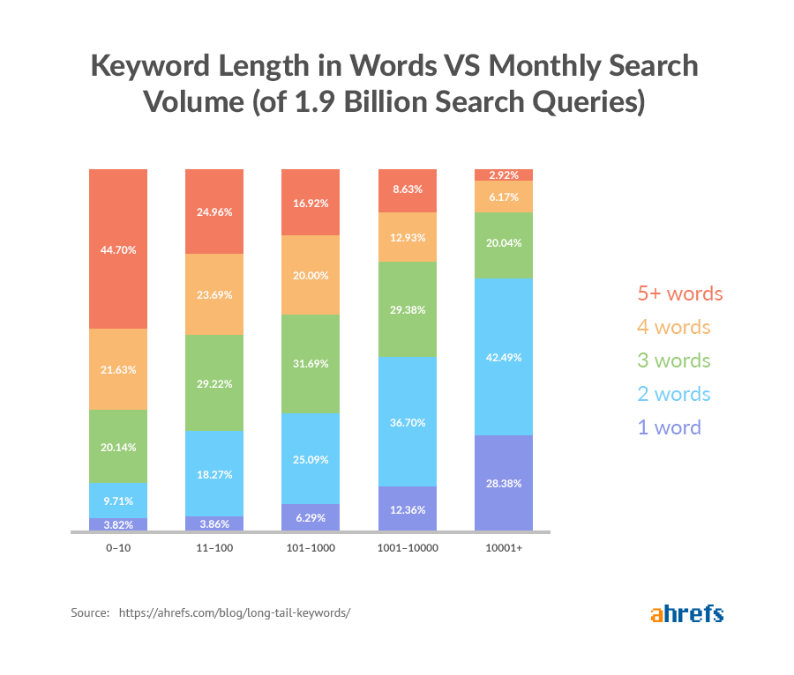

**How to choose keywords and keyword combinations for your app?**

**In order to make a list of keywords you want to optimize your app listing for, use app store optimization tools. Some example include KeywordTool, AppFollow and KeywordKeg.**

**4. Create an optimized app title:**

**As with search engine optimization, you need to ensure your app has a catchy title which incorporates keywords your potential users are likely to search for.**

**Note: In Google’s Play Store, you can only use 50 characters in your app store listing title.**

**Use them wisely. As such, you’ll need to keep your app name short, catchy and memorable, and easy to spell.**

**Next, include the most relevant keywords next to your brand name in the app’s title. If you’re unsure how to do this, use the keyword tools listed above, or go into the Play Store and look at your competitors’ listings.**

**Remember that localization works here as well. Certain keywords will perform better than others in different regions. Try using emoji’s in your app title to grab attention, but don’t use these at the expense of keywords.**

**5. Don’t overdo it with keywords in a short description:**

**While keywords are crucial in making your app discoverable, they shouldn’t be your primary focus in the short description. Especially since the short description can only be 80 characters long. Treat this part as the "elevator pitch" for your app. You have only a couple of seconds to catch your prospect’s attention, make a good first impression, and sell your app’s story. Naturally, you can mention a keyword or two – just make sure they don’t disrupt the message you’re trying to convey.**

**INSTAGRAM DOES A GREAT JOB AT THIS WITH THEIR CLAIM: “BRINGING YOU CLOSER TO THE PEOPLE AND THINGS YOU LOVE”.**

**6. Add social-proof and/ or statistics to your description:**

**If you are particularly proud of a certain stat or figure, or if you have an endorsement from a prestigious client, show it off in your Google Play Store listing!**

**Mentioning these can give you a credibility boost and differentiate you from your competitors – especially if the numbers or endorsement are visible above the fold.**

**See the example of Expedia’s Google Play profile:**

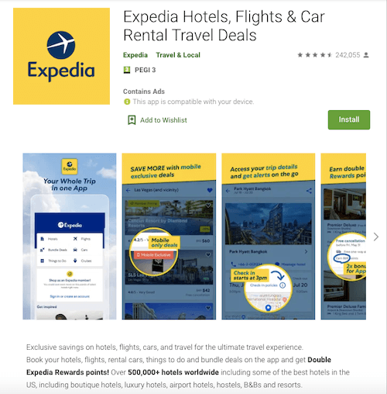

**The app creators made sure that anyone browsing through the listing notices that they have over half a million hotels available worldwide.**

### **7. Make sure your app icon stands out:**

**Making your visuals stand out from the crowd is one of the best ways of getting more hits in Google’s app store.**

**If you know your competitors, you can do this by using colours that contrast with their visual identity. Another approach is going for a bold statement and creating a brand that is unmistakable and instantly-recognizable.**

**A great example of this approach is Snapchat, with its bright yellow icon and key visuals:**

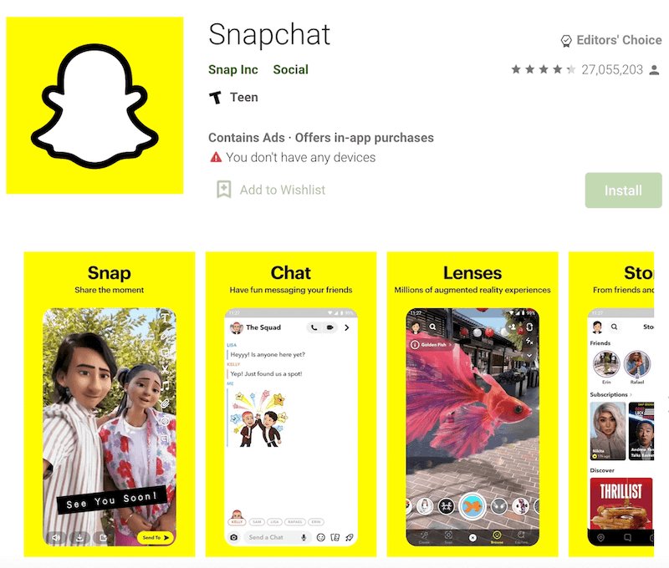

**8. Use keywords in your developer app name:**

**Another good place to use keywords is in the "developer name" field. Google tends to favour listings from app developers with more positive history and thus ranks them higher in search listings.**

**Consider using keywords in your developer name. For example, if you have released a free drawing app, consider adding the words ‘draw’ and ‘for free’ in the developer field, along with your developer name. Obviously, you need to make sure these fit, but it’s a handy way to achieve ASO.**

**9. Don’t rely on Google Play automatic translations:**

**To make it easy for you to be present on several markets quickly, Google offers automatic translations of listing descriptions. However, they recommend that you treat them as a temporary solution and hire a human translator.**

**This is because optimizing for multiple markets isn’t just about translating – it’s about localizing.**

**Localizing your app’s descriptions means you’ll have to perform separate keyword research for each market. A term that is easy and has a huge search volume in one country, might not be as simple to rank for and equally popular in the other.**

**For instance, according to UberSuggest, the keyword “food delivery app” has a search volume of 33,100 and difficulty score of 84 in the United States, whereas in Canada the volume is 1,900 and the difficulty score is 73.**

**This means that while the term is 17x as popular in US as it is in Canada, it’s also harder to rank for the phrase in the American market.**

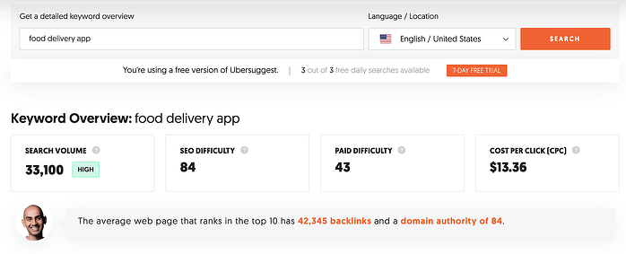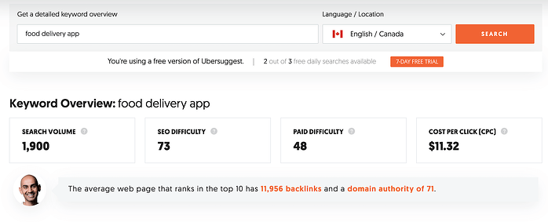

**REPORT CREATED BY**

**FAHAD IQBAL SHAH**

**PRODUCT MANAGEMENT INTERN**

**NOVO CABS**